Setting up Application Environment Create an account in Sendgrid

|  |  |
| --- | --- |
| **Team ID** | PNT2022TMID27972 |
| **Project Title** | Project - News Tracker Application |

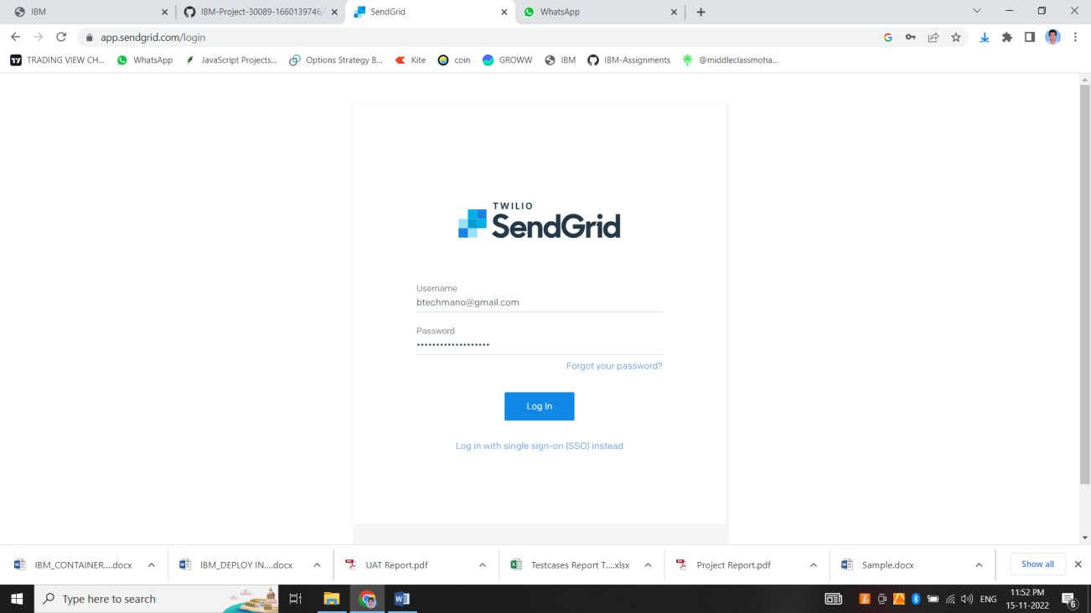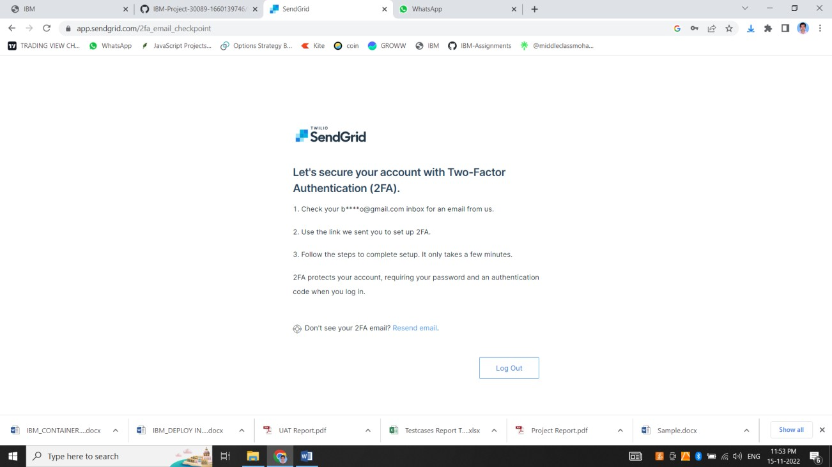

Thus we have created account in sendgrid